FLY OF THE MONTH - JUNE

THE DEER-HAIR FLOATING FRY

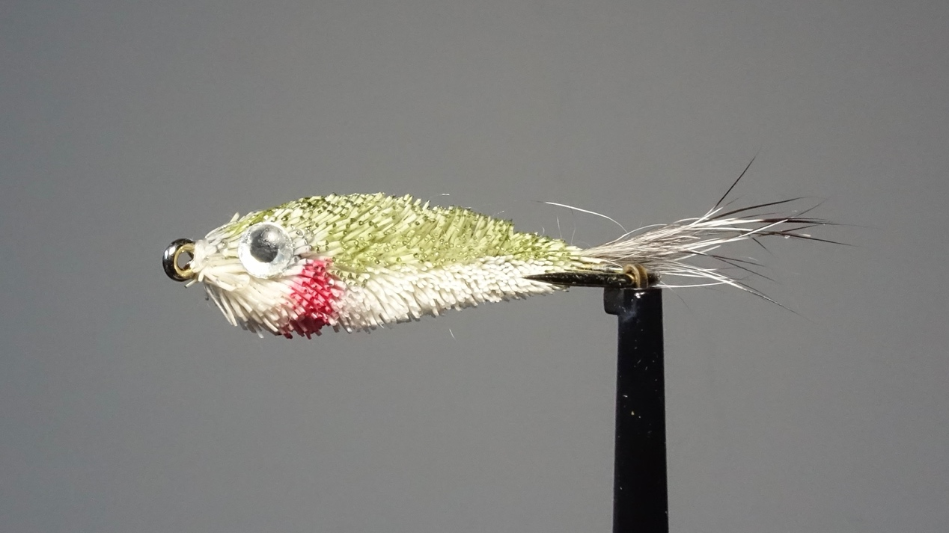

HOOK: Size 10 or 12 nymph

THREAD: White 6/0

TAIL: A small bunch of grey squirrel tail hair

BODY: White deer hair spun and clipped to shape

COLOUR: Red and olive felt tip pen

EYE: Stick-on 3D

This fly is tied to represent a small dead or injured fish floating on its side. The photo above is a trout’s view of the ‘fly’. It only needs one eye since the other would be invisible to the trout!

During the latter half of June and into July, you may come across fish feeding on pin fry. These will be perch or dace fry which are only about 15 - 20 mm in length. They are semi-transparent with prominent eyes, a silver belly and red around the gills. During calm conditions fry can be seen dimpling the surface in large shoals and the trout will not be far away.

Below: Pin fry spooned from a fish in June.

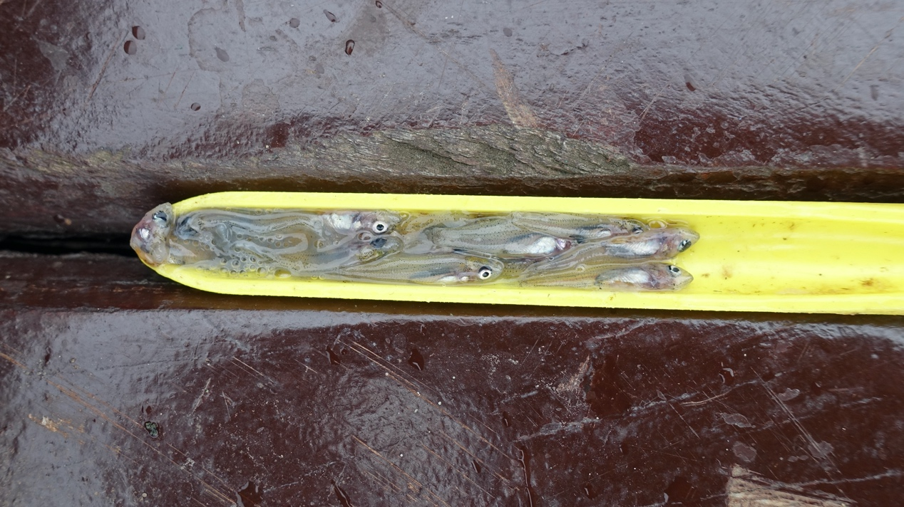

If you don't have any floating fry patterns in your box and you suspect fish are taking pinfry, try a Sinfoil’s Fry, Peter Ross, Butcher or a Silver Invicta, all of which look like small fish. Most flies mentioned in previous months will continue to work, especially those to imitate midge pupae which are now larger and in a wider variety of colours. For some reason the fish at Hallington seem to take a lot of empty midge shucks from the surface. They must have zero nutritional value and are extremely difficult to imitate since they are virtually transparent. I have caught one or two fish while experimenting with an all-white Shipman's buzzer fished in the surface film, but I wouldn't call it a great success.

From the end of May for a couple of months there will be some Mayfly hatching at the surface. These large upwing flies are easily imitated but I have generally found that the trout seem to be quite scared of such a large floating fly. The fish will often ignore them or just splash at them. Having said that I have spoken to other members at Hallington and some have had good fishing with dry mayflies. It is still worth trying a floating imitation if you see fish taking them but a nymph imitation such as Walker's Mayfly Nymph will probably produce more hook-ups.

Below: Detached Body Mayfly

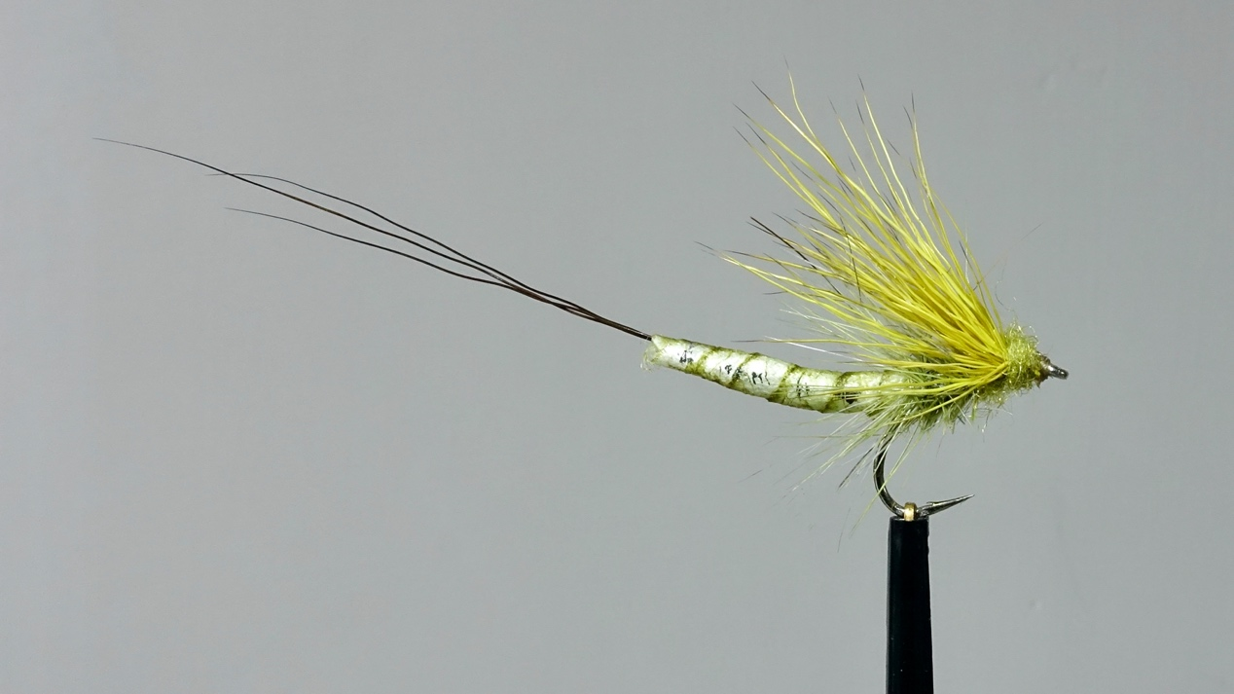

Another fly to look out for in June is the electric blue Damsel. The blue fly is the male, the female being a drab olive in colour. The nymph swims to shore to hatch, wiggling along just under the surface like a small fish. The trout love them and an imitation with an olive marabou tail fished off a floating line should catch when damsels are about. The nymphs prefer weedbeds but unfortunately there is not much weed in our reservoirs due to the fluctuating water levels, so damsel flies are not as prolific here as in some other local waters.

Phil Bilbrough

